GoMingle - Requirement Specification Document

Date: Sept 2026
Prepared for: GoMingle
Engagement Type: Fixed-Scope MVP Delivery

Table of Contents
Table of Contents 2
About Us 3
What We Do 3
1. Executive Summary 5
2. Understanding the Challenge (Business Context) 6
Current vs Target State 6
Business Outcomes and Value Drivers 7
3. Solution Architecture 8
3.1 Solution Architecture 8
3.2 Integration Architecture 9
3.3 Tech Stack 10
3.4 Security Architecture 11
4. Requirements Traceability Matrix & Scope Boundaries 12
4.1 Finalized MVP Feature Set 12
PRODUCT 1 — Mingler App (Flutter · Android) | 12
4.2 Out-of-Scope Exclusions (MVP) 23
5. Delivery Roadmap 24
Phase Overview 25
6. Project Cost Breakdown (Direct & Indirect Costs) 26
6.1 Direct Costs — Team Effort & Labor 26
6.2 Indirect Costs — Infrastructure, Tooling & Overheads 27
6.3 Total Project Cost 27
7. Risk Management 28
8. Project Sign-off 29
Approval 29

About Us
We are a three-member engineering team - Syed Rameez Ali, Rahim Ahmed Khan, and Sheikh Raees Raza - completing our MS Practicum at the National University of Computer and Emerging Sciences (NUCES), Karachi, under the supervision of Mr. Muhammad Kamran. This Technical Proposal is submitted as part of our practicum engagement, in which we act as the end-to-end delivery team for GoMingle's MVP, covering solution architecture, backend and mobile development, quality assurance, and delivery management.

What We Do
- End-to-End MVP Development: We design, build, and deliver the complete GoMingle platform — the Mingler mobile app (Flutter), Partner Portal, and Admin Panel (React.js) — from requirements through go-live.
- Solution Architecture & Cloud Infrastructure: We architect and provision the AWS-based backend (NestJS, containerized deployment, managed data stores) that supports the booking and payment lifecycle.
- Payment & Booking Systems Engineering: We implement the pre-authorization and no-show mechanic — the commercial engine of the GoMingle MVP — using PayPro/Safepay's payment APIs.
- UI/UX Design: We design the Mingler, Partner, and Admin experiences from wireframe through high-fidelity Figma prototypes.
- Quality Assurance & Testing: We author test cases and run functional and regression testing to validate the platform against agreed acceptance criteria before go-live.
- Academic Supervision & Governance: Our work is supervised by Mr. Muhammad Kamran at NUCES, so the engagement meets both academic practicum requirements and real-world delivery standards.

Category | Project Details
Requirements Looping | Collaborative Requirements Review subject to approved scope & Sign-Off — 4 Weeks
Specs & Design | Specs, Architecture & Design — 7 Weeks
Development | Single-Phase Full Build — 21 Weeks
Regression Testing | Full Regression Cycle — 3 Weeks
UAT | Stakeholder Acceptance Testing — 3 Weeks
Go-Live | Production Deploy & Stabilisation — 1 Weeks
Post Go-Live Support | Hypercare & 30-Day Bug-Free Warranty — 3 Weeks
Total Timeline | 42 Weeks (End-to-End)

1. Executive Summary
The Pakistan F&B sector hosts over 2600 licensed restaurants in Karachi alone, yet suffers from a structural, unresolved problem: no-shows. Industry estimates place the Pakistan restaurant no-show rate at 5-20% of all reservations, costing the sector hundreds of millions of PKR annually. Simultaneously, diners lack a trusted, social-first platform combining curated discovery, group coordination, and verified post-dining reviews.
The Complication for GoMingle: While GoMingle's vision to build a comprehensive social dining ecosystem is exactly what the market needs, executing the full vision upfront presents significant capital and execution risk. A multi-feature first launch defers validation of the core no-show mechanic.
The Resolution: We proposed a focused, 42-week MVP: discover → book → secure with card → dine → review. The no-show penalty mechanic — implemented via PayPro’s capture_method: manual pre-authorisation — is the commercial and legal cornerstone, built as a NestJS modular monolith on ECS Fargate with always-warm containers and persistent database connections.

2. Understanding the Challenge (Business Context)

Current vs Target State
Domain | Current State (As-Is) | Target State (To-Be) | Enabling Deliverables | Business Impact
Restaurant Discovery | Google Maps, TripAdvisor; fragmented; no real-time availability | Unified discovery with interest-based filters, amenity tags, geo proximity, map view with real-time slots | Mingler App, RestaurantModule, Elasticsearch, S3 + CloudFront | Single trusted discovery surface
Booking & Commitment | WhatsApp/phone; no digital confirmation; zero accountability | In-app booking wizard, slot selection, party config, pre-auth hold at confirmation | BookingModule, PayPro PaymentIntent (capture_method: manual) | Formal, timestamped commitment with legal enforceability
No-Show Penalty | No mechanism. Restaurants absorb 100% of loss. | @Cron task detects overdue CONFIRMED bookings every 15 min; captures PayPro pre-auth per empty seat | NoShowOrchestrator @Cron in BookingModule, PaymentModule | First-time revenue protection for Pak restaurants
Reviews & Trust | Unverified reviews; no post-dining verification gate | Post-dining payment unlocks review; verified diner badge; restaurant response view | ReviewModule, booking COMPLETED gate | 100% verified diner reviews
Restaurant Operations | Paper reservation books, manual no-show logging | Partner Web Portal: booking dashboard, arrival marking, no-show triggering, policy config | Partner Portal (React.js), BookingModule, RestaurantModule | Operational digitisation
Platform Governance | No platform layer; no onboarding standards | Admin Panel: onboarding approval, fee config, payout oversight, analytics | Admin Panel (React.js) | Scalable marketplace from day one

Business Outcomes and Value Drivers
Restaurant Revenue Protection: Pak F&B average cover is PKR 2500–4000. A no-show on a table of four represents PKR 10,000–20,000 in lost revenue — recoverable via the pre-auth mechanic.
Platform Fee Revenue from Day One: The post-dining in-app payment flow enables a platform transaction fee on every completed bill.
Verified Review Moat: The post-payment review gate creates a review corpus structurally impossible to fake.
Data Foundation for Phase 2: Every booking, arrival, no-show, and review generates the dataset required for AI analytics and dynamic pricing.

3. Solution Architecture

3.1 Solution Architecture
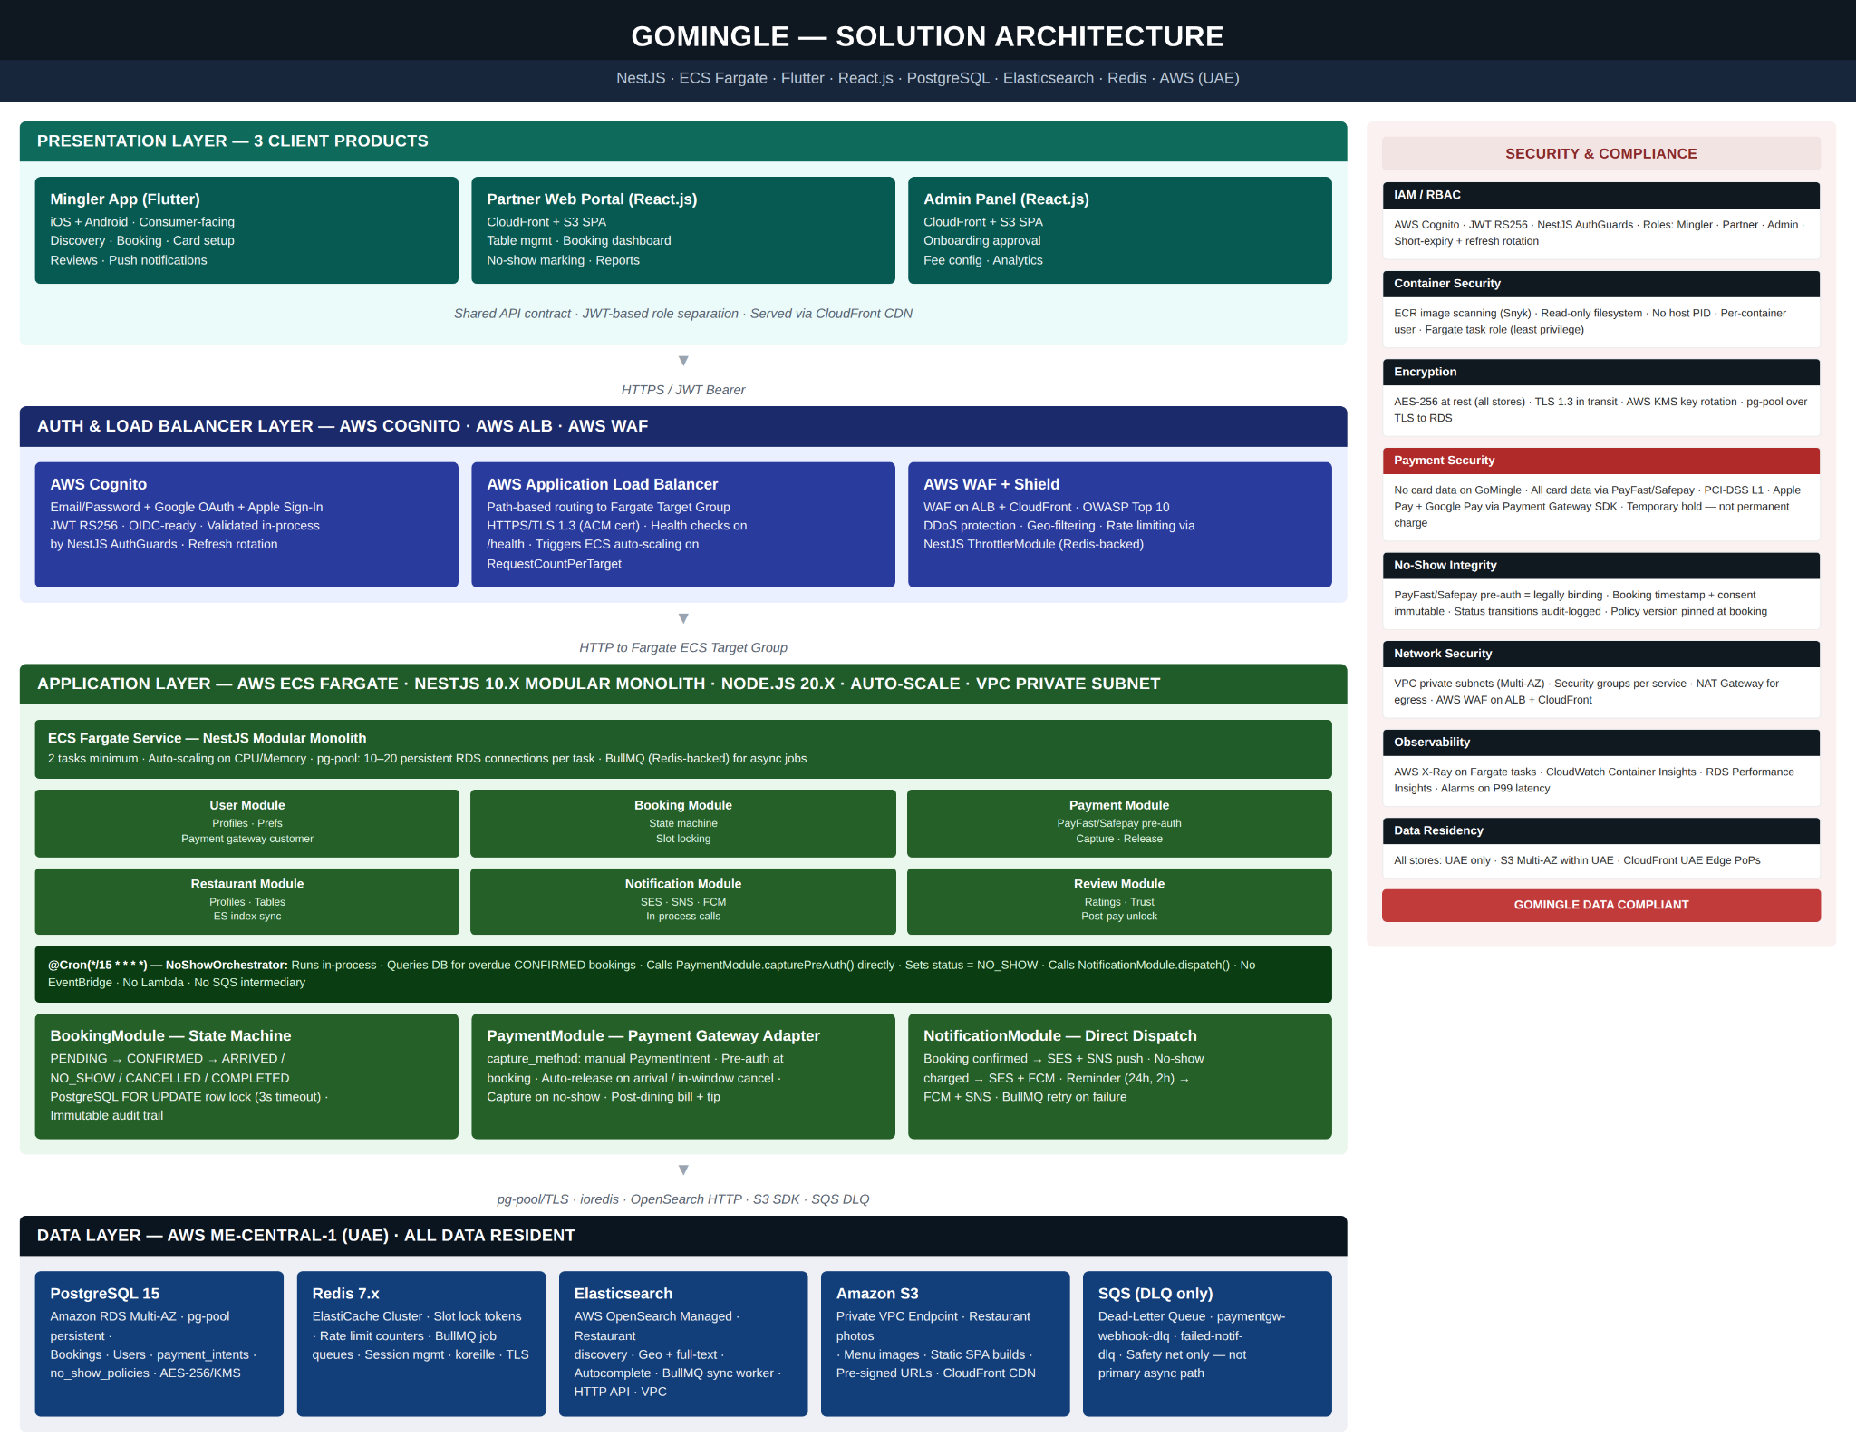
GoMingle is designed as a cloud-native, container-first platform deployed on AWS. The platform runs as a NestJS modular monolith on ECS Fargate, no cold starts, persistent database connections via pg-pool, behind an Application Load Balancer.

3.2 Integration Architecture

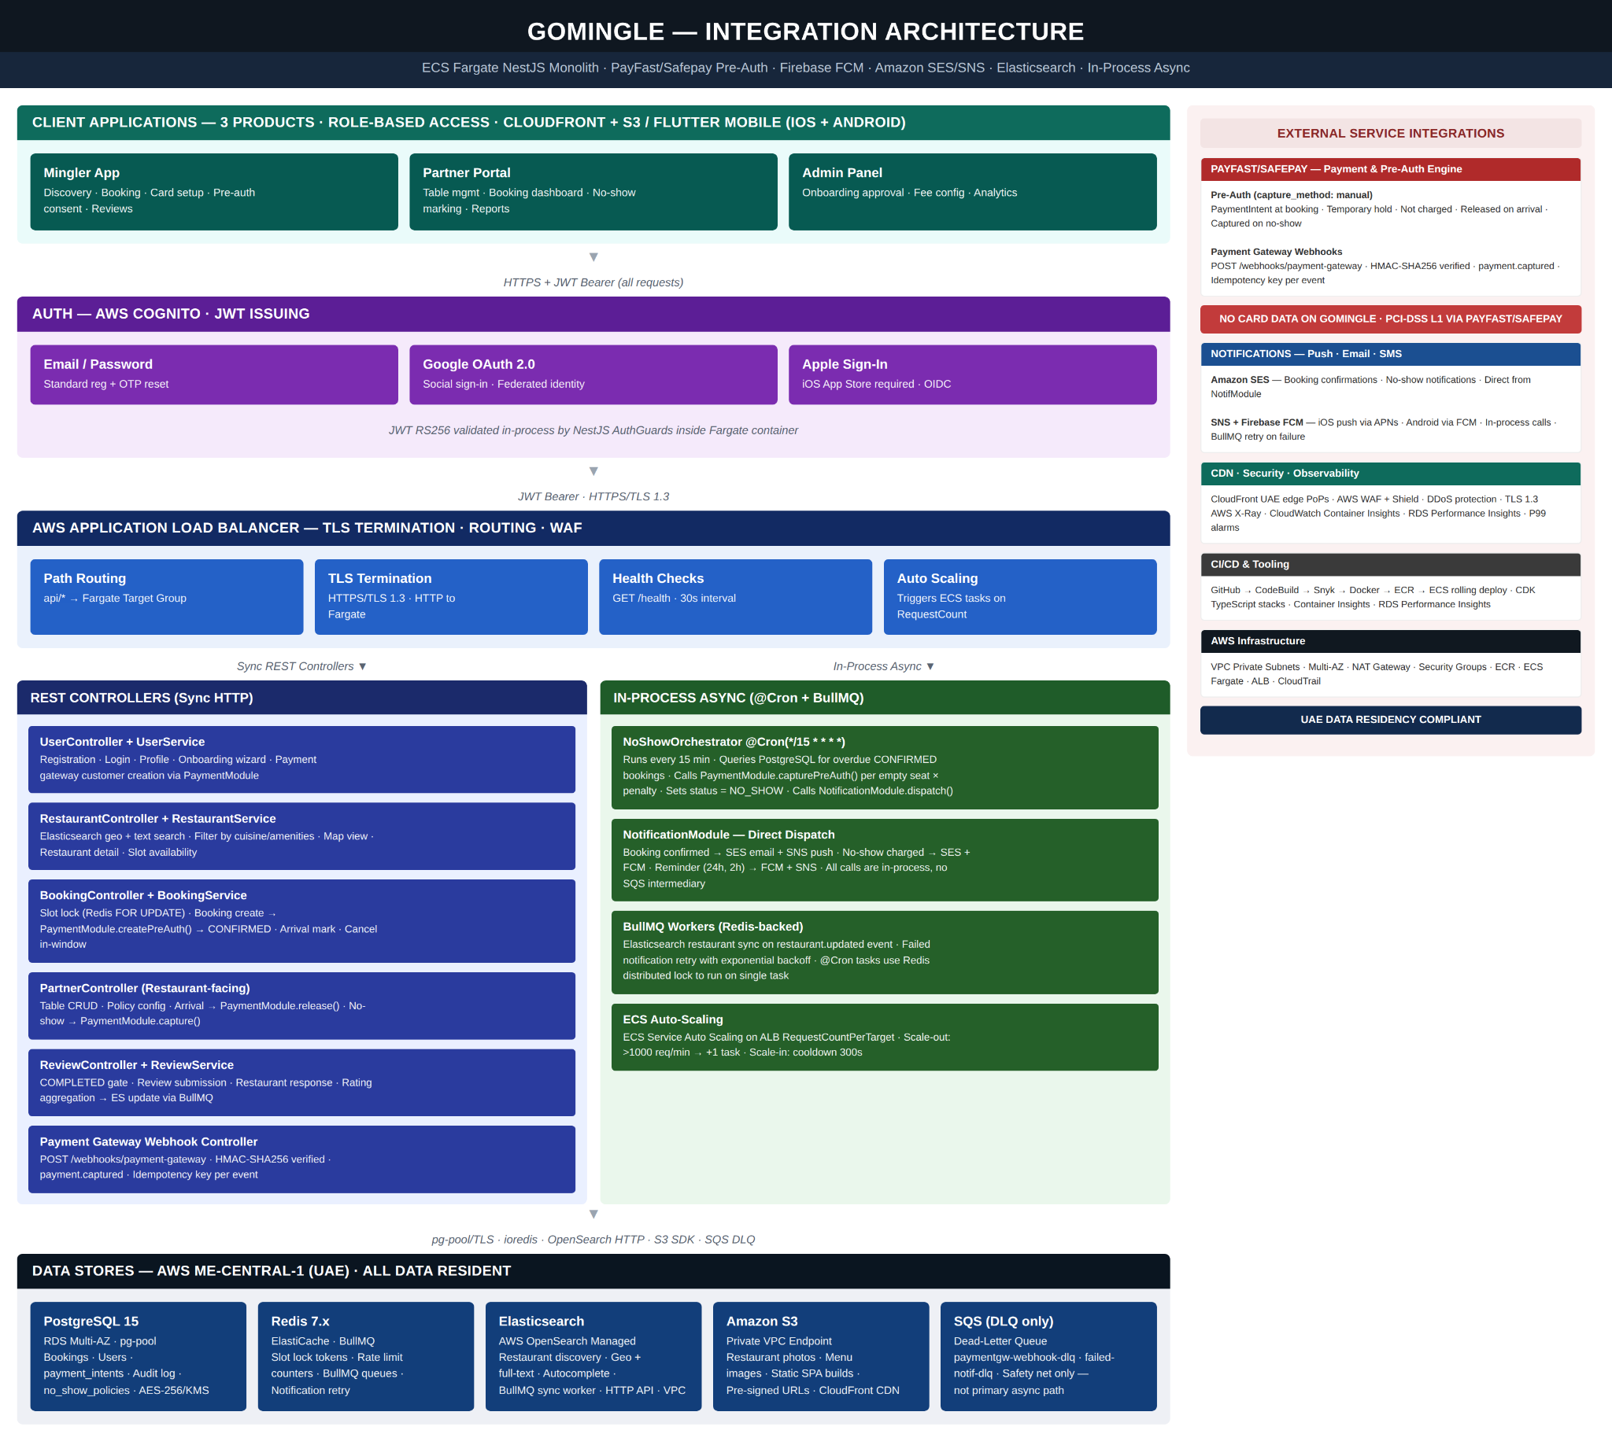

3.3 Tech Stack
Layer | Technology | Rationale
Mobile App | Flutter (Android) | Single codebase for Mingler App. Native-feel performance. Dart strong-typing reduces runtime errors.
Web (Portal + Admin) | React.js SPA | CloudFront + S3 hosting. Component reuse across Partner Portal and Admin Panel.
Backend | NestJS 10.x on ECS Fargate | TypeScript end-to-end. Modular monolith — clean NestJS module boundaries with in-process calls. pg-pool to RDS. @Cron for NoShowOrchestrator. BullMQ for async jobs.
Database | PostgreSQL (Amazon RDS) | Managed service. Multi-AZ for HA. Row-level locking for slot concurrency control.
Search | Elasticsearch (AWS OpenSearch) | Restaurant discovery — geo queries, full-text, autocomplete. Managed service.
Cache | Redis 7.x (ElastiCache Cluster) | Slot locking, session management, rate limiting, BullMQ job queues.
Auth | AWS Cognito | Email/password. JWT RS256. OIDC-ready.
Load Balancer | AWS ALB | Path-based routing to ECS Fargate. TLS 1.3 via ACM. Health checks. JWT validated in-container by NestJS AuthGuards.
Payments | PayPro (PaymentIntents API) | Pre-auth with capture_method: manual is the legal cornerstone.
Notifications | Amazon SES + SNS + Firebase FCM | SES for email. SNS bridges to iOS APNs. FCM for Android push. All dispatched in-process from NotificationModule.
Storage + CDN | Amazon S3 + CloudFront | Restaurant photos, SPA builds. Pre-signed URL access.
Async Processing | BullMQ (Redis-backed) + SQS (DLQ only) | BullMQ handles all async jobs using the existing Redis instance. SQS retained only as dead-letter queue for failed jobs requiring manual inspection.
CI/CD | AWS CodePipeline + GitHub + AWS CDK | GitHub → CodeBuild → Snyk → Docker → ECR → ECS rolling deploy. CDK TypeScript stacks.
Observability | AWS X-Ray + CloudWatch Container Insights | Distributed tracing on Fargate tasks. RDS Performance Insights. P99 latency alarms.
Loyalty Engine | Open Loyalty (SaaS API) | Points earn, redeem and ledger management via REST API. Eliminates need to build a custom loyalty engine for MVP. Configurable rules managed by Admin Panel.

3.4 Security Architecture
3.4.1 Identity & Access Control: OAuth 2.0 / OIDC via AWS Cognito; JWT RS256 tokens validated in-process by NestJS AuthGuards. RBAC with three primary roles: Mingler (consumer), Partner (restaurant), Platform Admin. Session management with device-bound refresh tokens; anomaly detection on concurrent logins.
3.4.2 Data Protection: Encryption at rest: AES-256 for all data stores (RDS, ElastiCache, S3) via AWS KMS with automatic key rotation. Encryption in transit: TLS 1.3 for all external communications; pg-pool connections over TLS to RDS. No card data stored on Go Mingle infrastructure. All payment data handled entirely by PayPro.
3.4.3 Audit Trail & Observability: Immutable audit log for all booking lifecycle events (append-only; no DELETE/UPDATE on audit table). Structured logging with correlation IDs across all six NestJS modules. AWS X-Ray distributed tracing on Fargate tasks; CloudWatch Container Insights; RDS Performance Insights.
3.4.4 Standard Security Practices: We will be using secure-by-design principles. OWASP Top 10 vulnerability scanning and mitigations actively applied to both the Flutter mobile application and all NestJS backend APIs via Snyk in the CI/CD pipeline.

4. Requirements Traceability Matrix & Scope Boundaries

4.1 Finalized MVP Feature Set

PRODUCT 1 — Mingler App (Flutter · Android) |
F1 — Authentication & Profile
# | Sub-Feature | Description
1.1 | Email & password registration | User enters email and creates a password. Email verification OTP required before account activation. Passwords hashed; never stored in plain text. AWS Cognito handles user pool, token issuance and session management.
1.2 | Password reset via OTP | User enters registered email; system sends 6-digit OTP with 10-minute expiry. OTP verified in-app, then new password set. Cognito handles OTP generation and verification. Failed attempts beyond threshold temporarily blocked.
1.3 | User profile edit | Authenticated user can update display name, profile photo, city/location, food preferences (cuisine types), dietary restrictions, allergy flags and amenity preferences (e.g. valet, kids area, outdoor seating). Profile photo uploaded to S3 with CDN-served URL. Changes reflected immediately.
F2 — Payment Setup
# | Sub-Feature | Description
2.1 | Credit / debit card via PayPro | Card tokenised using PayPro Elements / PayPro SDK. PayPro returns a payment method ID — only this ID is stored by GoMingle; no card number, CVV or expiry. Multiple cards can be saved with one set as default. Cards removable at any time.
2.2 | No-show pre-authorisation hold | PayPro PaymentIntent created in capture_method: manual mode at booking confirmation. Hold amount = restaurant's configured penalty per seat × number of adult seats booked. Card is not charged — only a hold placed on available balance. Released on arrival; fully or partially captured on confirmed no-show.
2.3 | Cancellation within window — auto release | If the Mingler cancels within the configured cancellation window, the PayPro PaymentIntent is cancelled and the pre-auth hold released on the set schedule — user sees confirmation of no charge. If cancelled outside the window, penalty capture is triggered. System checks booking timestamp against configured window at moment of cancellation.
2.4 | Post-dining in-app payment | Restaurant closes the session from Partner Portal, triggering a payment prompt in the Mingler app. User sees itemised bill total with configurable tip selector (10%, 15%, 20% or custom). Payment via saved card. PayPro processes the payment and splits the net amount to the restaurant via PayPro Connect after deducting the GoMingle platform fee. Digital receipt generated and stored on the booking record.
2.5 | Penalty charge confirmation to Mingler | When a no-show penalty is captured, system immediately sends Mingler a push notification and transactional email. Both include restaurant name, booking date/time, number of empty seats, penalty per seat, total amount charged and a link to the in-app dispute flow. Charge appears in booking history with a "No-show penalty" status label.
F3 — Restaurant Discovery
# | Sub-Feature | Description
3.1 | Location-based discovery | App passes device GPS coordinates to RestaurantService which performs a PostGIS radius query on RDS. Restaurants returned sorted by distance. Results cached in ElastiCache Redis. Home screen shows curated list of nearby restaurants with distance in kilometres.
3.2 | Search by name / Interest / type | Persistent search bar accepts free-text. Full-text search across restaurant names, interest tags, and descriptions using pg_trgm similarity matching in PostgreSQL. Results update as the user types with debounce delay. Recent searches stored locally on device.
3.3 | Restaurant listing card | Each result displayed as a card showing cover photo, restaurant name, cuisine type tag, aggregate star rating, review count, distance from current location and a VIP table badge if VIP tables are configured and available. Cards load progressively with image lazy-loading via CloudFront CDN.
3.4 | Restaurant detail page | Full restaurant profile: swipeable photo gallery, name, cuisine, description, opening hours, amenities list, menu highlights (categories and items with photos and prices), aggregate rating with review count, individual verified reviews and available time slots for next 7 days. "Book Now" CTA fixed at bottom. VIP badge with pricing differential shown if VIP tables available.
3.5 | Map view | Map tab/toggle shows Google Maps embedded view with custom restaurant pins. Tapping a pin shows a preview card (name, rating, distance); tapping the card opens the full detail page. Map auto-centres on the user's current location. As user pans or zooms, restaurants within the new viewport are fetched dynamically using a bounding box PostGIS query.
F4 — Interest Table Discovery & Joining
# | Sub-Feature | Description
4.1 | Home Feed Discovery | The home screen presents two dynamic sections: "Happening Now" (Interest Tables starting within the user's chosen time window — default 24 hours, customisable to next 2 days, week, or month) and "Near You" (tables within a configurable distance radius). Each IT card shows: cover image (horizontal), IT name, topic/interest tag, restaurant name, distance, date/time, current seat count, and a "Join Table" CTA. A "Curated for You" section appears once the user has set interests. Cards display a "Promingled by [name]" label when a ProMingler is assigned.
4.2 | Interest Table Detail Page | Two-tab layout: "Table Details" (primary) and "Restaurant Details" (secondary). Table Details shows: IT name, topic/interest, date/time, ProMingler profile (if assigned), set menu options, capacity status (seats filled / total), bookable state (Join Table / Coming Soon / Fully Booked), and a prominent "Join Table" CTA. Restaurant Details tab shows: photo gallery, cuisine type, opening hours, amenities, and location map.
4.3 | Search and Filters | Persistent search bar for free-text search across IT names, topics, and restaurant names. Eight filter options: Location/Near Me (customisable radius), Interest (category), Date, Day of week, Price, Time of day, Captain seat available, and ProMingler filter. Filter icon sits beside the search text box. Sponsored and restaurant rating filters removed.
4.4 | Joining a Table | The user taps "Join Table" and completes a streamlined join flow. A PayPro pre-auth card hold is placed immediately at booking. Booking status displays as "Confirmed" to the Mingler immediately after joining — the internal "Waiting for Confirmation" status is never shown to the Mingler. Users cannot join two ITs with the same or overlapping start/end times (enforced with a 409 conflict error). ProMingler bookings are auto-created and auto-confirmed with no payment required.
4.5 | Captain Claim | If no ProMingler is assigned to an IT, the first Mingler to book sees an option to become the Table Captain. The Captain facilitates the dining experience and earns a fixed 50-point loyalty bonus when the IT reaches Completed status. Only one Captain per table. If no Captain is claimed before the event, admin assigns one manually.
4.6 | IT Booking Status & Visibility | Each Interest Table has one of three admin-controlled states: Bookable (visible to all users, "Join Table" active), Not Bookable / Coming Soon (visible to all, "Coming Soon" label — no booking allowed), or Invite-Only (visible only to admin-selected Mingler accounts; admin manually emails the IT shareable link; first Minglers to click and book get seats). All cancellation and window rules apply identically across all three states.
4.7 | Cancellation and Auto-Cancel Rules | Cancellation is free before the 24-hour mark — card hold released in full, loyalty points refunded if previously redeemed. Once the 24-hour confirmation trigger fires and the IT moves to Confirmed status, no further cancellations are permitted by anyone. If the minimum seat count is not met at the 4-hour mark, the entire IT is auto-cancelled — all holds released, all Minglers notified. No new bookings accepted within 2 hours of event start.
4.8 | Booking History | Dedicated screen showing all past and upcoming Interest Tables in chronological order. Each entry shows IT name, restaurant, date/time, and booking status (Confirmed, Completed, Cancelled). Upcoming confirmed entries show a countdown. Cancelled entries display the reason (self-cancel, 4-hour auto-cancel, or cascade cancellation from account suspension). Tapping an entry opens full IT detail including any charges applied.
F5 — Verified Reviews
# | Sub-Feature | Description
5.1 | Post-event review prompt | ReviewService triggers a push notification after the IT reaches Completed status. Deep-links to the review submission screen for that specific event. Each booking generates at most one review; repeat prompts suppressed. After submitting a review, users see a "Let's do it again" Yes/No prompt for all table types (default: Yes), enabling easy rebooking at the same restaurant or a similar IT.
5.2 | Star rating & comment | Review screen shows restaurant name and booking date. User selects 1–5 star rating via tap-to-select. Optional free-text comment up to 500 characters. Photo upload not included in MVP. Review stored against booking ID in RDS permanently linking it to the verified visit. Submitted reviews cannot be edited but can be deleted by the user within 24 hours.
5.3 | Review display on restaurant page | Restaurant detail page shows aggregate star rating prominently near the top. Reviews section lists individual reviews in reverse chronological order: reviewer first name and last initial, star rating, review text and date. Each review carries a "Verified Diner" badge. Restaurants with no reviews show a placeholder prompting the first booking.
F6 — Notifications
# | Sub-Feature | Description
6.1 | Booking Confirmation | Sent immediately when a Mingler successfully joins an Interest Table. Delivered via WhatsApp (Twilio) as the primary channel, plus SendGrid email if the user has provided an email address. FCM push notification also sent. Contains: IT name, restaurant, date/time, seat count, pre-auth hold amount, and cancellation policy (free cancellation until 24 hours before event).
6.2 | Event Confirmed | Sent when an IT reaches Confirmed status — i.e., the 24-hour trigger fires and the minimum seat count is met. Notifies all booked Minglers that the event is confirmed and their card hold has been captured as a charge. Delivered via WhatsApp + SendGrid email (if provided) + FCM push. Also notifies the restaurant that the event is confirmed and the guest list is finalised.
6.3 | 4-Hour Auto-Cancel | Dedicated notification sent to all registered Minglers and the linked restaurant when an IT is auto-cancelled at the 4-hour mark due to insufficient bookings. Confirms that card holds have been released and loyalty points redeemed have been refunded. Booking status for all participants moves to Cancelled.

F7 — Loyalty Program
# | Sub-Feature | Description
7.1 | Points earning | Loyalty points are awarded when an Interest Table reaches Completed status — not at booking or at Confirmed stage. Earn rate is admin-configurable (e.g. 1 point per PKR 1 of booking value). Captain earns a fixed 50-point bonus in addition to standard earn when the IT reaches Completed. ProMinglers earn NO loyalty points — their free dining experience is their compensation. Points ledger managed via Open Loyalty API.
7.2 | Points redemption at checkout | During the booking join flow, the Mingler sees their available points balance and equivalent PKR discount value. Minimum redemption threshold must be met before redemption is enabled. PayPro PaymentIntent adjusted to reflect the points discount before the pre-auth hold is placed. Points deducted from the Open Loyalty ledger immediately on successful booking. Points redeemed at booking are refunded in full on any cancellation (self-cancel, auto-cancel, or cascade).
7.3 | Points balance and history | Dedicated Loyalty screen (labelled "Rewards" in the bottom navigation) accessible from the Mingler app. Shows current points balance and a full transaction history of all earn and redeem events in reverse chronological order. Each entry shows the source (IT name or event), points earned or redeemed, and running balance. Data fetched from the Open Loyalty API in real time.

PRODUCT 2 — Partner Web Portal (React.js) | 4 Features · 9 Sub-Features
F7 — Restaurant Profile Management
# | Sub-Feature | Description
7.1 | Restaurant profile setup | Structured profile form covering restaurant name, short description, cuisine type (selectable tags), full address with map pin (Google Maps Places API), opening hours per day including special holiday hours, amenities checklist (valet, kids area, outdoor seating, live music, pool access, parking, etc.) and cover photo plus gallery images (uploaded to S3, served via CloudFront). Powers listing card and detail page in Mingler app. Editable at any time; changes reflected in app within minutes.
7.2 | Restaurant registration & approval flow | New eatery completes registration form: business name, owner name, contact details, trade licence number and document uploads (trade licence, food safety certificate). Submission triggers notification to Admin Panel for review. On approval: account activated, welcome email sent, restaurant appears in Partner Portal dashboard. On rejection: reason provided, applicant can resubmit. Status (Pending, Approved, Rejected) visible in portal at all times.
F8 — Table Availability Submission
# | Sub-Feature | Description
8.1 | Table information submission | Restaurant owner submits available tables to the platform for the admin team to use when creating Interest Tables. Submission includes: table name or number (e.g. Table 1, Window Booth), seating area designation (indoor/outdoor), maximum capacity, and preferred time slots per day. Restaurants do not create Interest Tables directly — they provide availability data that admin uses during IT creation. Submitted changes are reflected in the admin's IT creation tool within minutes.
8.2 | Availability calendar | Owner sets available time slots per table on a day-by-day basis using a weekly schedule builder (e.g. every Tuesday 6 pm–10 pm in 90-minute slots), with specific date overrides for holidays or events. This availability data surfaces to admin during IT creation and scheduling. Restaurants cannot cancel or modify existing confirmed Interest Tables — that is admin-only authority.
8.3 | Table area and capacity config | Restaurant owner defines seating areas (e.g. Terrace, Indoor Main, Private Room) and the tables within each area. Each table has a name, capacity, and indoor/outdoor designation. This area structure helps admin select the most appropriate table when creating an IT. Table configurations can be edited at any time; changes do not affect already-confirmed ITs.
F9 — IT Booking View
# | Sub-Feature | Description
9.1 | Upcoming Interest Tables | Main operational screen showing all Interest Tables scheduled at the restaurant, sorted chronologically with today's events highlighted. Each entry shows: IT name, topic/interest, date/time, ProMingler (if assigned), Mingler count (confirmed seats vs capacity), and IT status (Pending, Confirmed, Completed, Cancelled). Auto-refreshes every 60 seconds. Filterable by date range.
9.2 | Guest list view | Tapping an IT shows the guest list for preparation: Mingler first names, food preferences and dietary restrictions (from the Go Mingle preferences tab), allergy flags (highlighted in red), and Captain designation. Restaurant staff use this view for table setup and menu preparation. They cannot modify bookings, cancel ITs, or contact Minglers directly from this view.
9.3 | Event start confirmation | Restaurant staff mark the event as started ("Guests Arrived") from the dashboard once Minglers are seated. This triggers the post-dining review prompt flow at event completion and updates the IT status to Completed on the platform. Only one confirmation action is required — the system handles downstream notification and loyalty point award automatically.
9.4 | Restaurant profile setup | Structured profile form covering restaurant name, short description, cuisine type (selectable tags), full address with map pin (Google Maps Places API), opening hours per day including special holiday hours, amenities checklist (valet, kids area, outdoor seating, live music, pool access, parking, etc.) and cover photo plus gallery images (uploaded to S3, served via CloudFront). Powers listing card and detail page in Mingler app. Editable at any time; changes reflected in app within minutes.
9.5 | Restaurant registration and approval flow | New restaurant completes a registration form: business name, owner name, contact details, trade licence number, and document uploads (trade licence, food safety certificate). Submission triggers a notification to the Admin Panel for review. On approval: account activated, welcome email sent. On rejection: reason provided, applicant can resubmit. Status (Pending, Approved, Rejected) visible in the portal at all times.
F10 — No-Show Policy [REMOVED FROM SCOPE]
# | Sub-Feature | Description
10.1 | REMOVED — No-Show Penalty Mechanic out of scope | The no-show penalty mechanic has been removed from Phase 1 scope following CR-MET-002 and subsequent scope decisions. Restaurants do not configure penalty amounts or cancellation windows in Phase 1. The pre-auth hold at Interest Table booking is platform-managed and relates to seat reservation commitment, not no-show penalties. No-show penalty enforcement is deferred to Phase 2.
10.2 | REMOVED — see 10.1 | See 10.1. No-show penalty configuration is out of scope for Phase 1 MVP.

F11 — Revenue Reports
# | Sub-Feature | Description
11.1 | Basic revenue reports | Reporting dashboard with weekly and monthly views. Metrics: total Minglers hosted across all Interest Tables at this restaurant, total ITs completed vs cancelled, average IT occupancy rate (confirmed seats / capacity), and total revenue processed through Go Mingle at this restaurant. Filterable by date range. Data pulled from RDS via a read replica. No no-show penalty metrics — that mechanic is out of scope for Phase 1.

PRODUCT 3 — Admin Panel (React.js) | 5 Features · 11 Sub-Features
F12 — Restaurant Management
# | Sub-Feature | Description
12.1 | Onboarding approvals | Admin Panel shows a queue of pending restaurant registration applications with submitted business details, uploaded documents (trade licence, food safety certificate) and a timestamp. Ops team can approve (activates account, sends welcome email) or reject with a written reason (sends rejection email with resubmission instructions). Full log of all approval and rejection actions maintained with timestamps and admin user IDs.
12.2 | Restaurant account management | Admins can search and view any restaurant account. Admins can edit profile information, temporarily suspend an account (removes restaurant from Mingler discovery and blocks new bookings while preserving existing bookings and historical data) or permanently deactivate an account. All suspension and deactivation actions require a written reason which is logged. Suspended restaurants receive an email notification with reason and contact information for resolution.
F13 — User Management
# | Sub-Feature | Description
13.1 | Mingler account management | Admins can search Mingler accounts by name, email or phone number. Account detail view shows registration date, number of IT bookings, total spend, and ProMingler status. Admins can suspend an account (blocks new bookings and login while preserving data) or permanently delete an account in compliance with data protection requests (GDPR / UAE PDPL1). All payment methods associated with a deleted account are detached from PayPro. Suspension/deletion log maintained. Admins can promote a Mingler to ProMingler role, adding them to the ProMingler pool available during IT creation.
13.2 | ProMingler management | Admins can search and filter Mingler accounts to find ProMingler-tagged users. ProMingler promotion: admin selects a Mingler account and activates the ProMingler flag — this adds them to the ProMingler pool available during IT creation. Each ProMingler has a profile visible to other Minglers showing: profile picture, name, gender, interests, industry, job title, and age. Admins can revoke ProMingler status at any time. Phase 1 targets approximately 50 hand-picked ProMinglers onboarded internally.
F14 — Finance
# | Sub-Feature | Description
14.1 | Platform fee configuration | Admins set the platform commission structure: a percentage of each confirmed booking value processed through Go Mingle. Rates applied automatically by PaymentService when processing PayPro Connect payouts to restaurants. Separate rates can be configured for standard and ProMingler-hosted ITs. Rate changes take effect on new transactions only. Full history of rate changes maintained with timestamps and admin user IDs.
14.2 | Revenue overview | Platform-level financial dashboard. Metrics: total Interest Table bookings, total pre-auth holds placed (at booking), total revenue captured at Confirmed status (holds converted to charges), cancellation refund volume, and total platform fees collected. Data sourced from PayPro Connect via PayPro API and cross-referenced with RDS bookings table. Read-only — no financial actions taken from this view.
14.3 | Payout oversight | Admins can view payout status for every connected restaurant PayPro account. Overview shows: restaurant name, total pending payout amount, last payout date, last payout amount, and account status (active, restricted, pending verification). Restricted or problematic accounts flagged in red. Admins can view PayPro-level detail but cannot initiate or modify payouts directly — those are managed through the PayPro Connect dashboard.

F15 — Loyalty Configuration
# | Sub-Feature | Description
15.1 | Points and redemption configuration | Admin configures all global loyalty rules via the Admin Panel, which writes to the Open Loyalty API. Configurable parameters: points earned per PKR of booking value at IT Completed status, Captain fixed bonus points (default: 50 points), redemption rate (points-to-PKR conversion, e.g. 100 points = PKR 5), and minimum redemption threshold (e.g. minimum 500 points before a Mingler can redeem). ProMingler point earn is permanently set to zero and is not configurable. All changes logged with timestamps and the admin user ID who made the change.

F16 — Interest Table Management

# | Sub-Feature | Description
16.1 | Interest Table creation | Admin creates all Interest Tables — restaurants do not create ITs directly. Creation form includes: IT name (required, max 80 characters), topic/interest category (from the admin-managed category list), linked restaurant, date and time, minimum and maximum capacity (with ProMingler assigned: min 4 total inclusive, max 8 total inclusive; Captain-only flow: min 3, max 6), optional ProMingler assignment (from the approved ProMingler pool), set menu assignment (optional), and initial bookable status (Bookable / Not Bookable — Coming Soon / Invite-Only).
16.2 | IT status and visibility management | Admin can update an IT's status at any time. Bookable: visible to all users, "Join Table" button active. Not Bookable / Coming Soon: visible to all users, "Coming Soon" label shown, no booking allowed — used while ProMingler logistics are being confirmed before going live. Invite-Only: visible only to admin-selected Mingler accounts; admin manually emails the direct IT link; first eligible Minglers to click and book get seats (no accept/decline — pure first-come-first-served). All cancellation, confirmation window, and auto-cancel rules apply identically across all three states.
16.3 | Interest category management | Admin can add, edit, and remove interest categories (full CRUD) via the admin portal. Categories are used as topic tags for Interest Tables and as filter options in the Mingler app home feed and search. The admin portal categories section exactly mirrors what appears in the mobile app — changes take effect immediately. Invited Minglers must already have active accounts in the system. No in-app invitations section in Phase 1 — invites are sent manually by admin via email with a direct link.

4.2 Out-of-Scope Exclusions (MVP)
Exclusion | Category | Description — explicitly OUT OF SCOPE for MVP
Gamification & Referrals | Consumer | Tier/badge system and in-app promotions. Phase 2. Core loyalty earn and redemption (F7) are in scope. Note: iOS referral tracking is pending a client decision (iOS App Store does not natively record referral codes; a web-based sign-up flow with referral token is under evaluation).
Events Module | Consumer | Cooking classes, sponsored brand events, group dining events, event ticketing. Phase 2.
AI-Powered Analytics | Platform | AI-driven revenue optimisation, occupancy forecasting, menu performance analytics. Phase 2.
POS Integration | Restaurant Ops | Square, Toast, Lightspeed or any POS system integration. Phase 2.
Eatery Mobile App | Restaurant Ops | Native Flutter app for restaurant floor operations. Partner Web Portal sufficient for MVP. Phase 2.
In-App Dispute Resolution | Platform | Removed from scope. The no-show penalty mechanic itself has been removed from Phase 1 scope, making this module redundant for MVP.
Dynamic Pricing | Revenue Management | Automated peak/off-peak table pricing rules triggered by occupancy or demand. Phase 2. Note: manually-configured table pricing differentials (Standard / Premium / Discounted) per F8.2 are in scope.
Content & Legal | Governance | Marketing content, Terms of Service drafting, privacy policy review, App Store listing copy and trade licence verification are Go Mingle's responsibility.

5. Delivery Roadmap
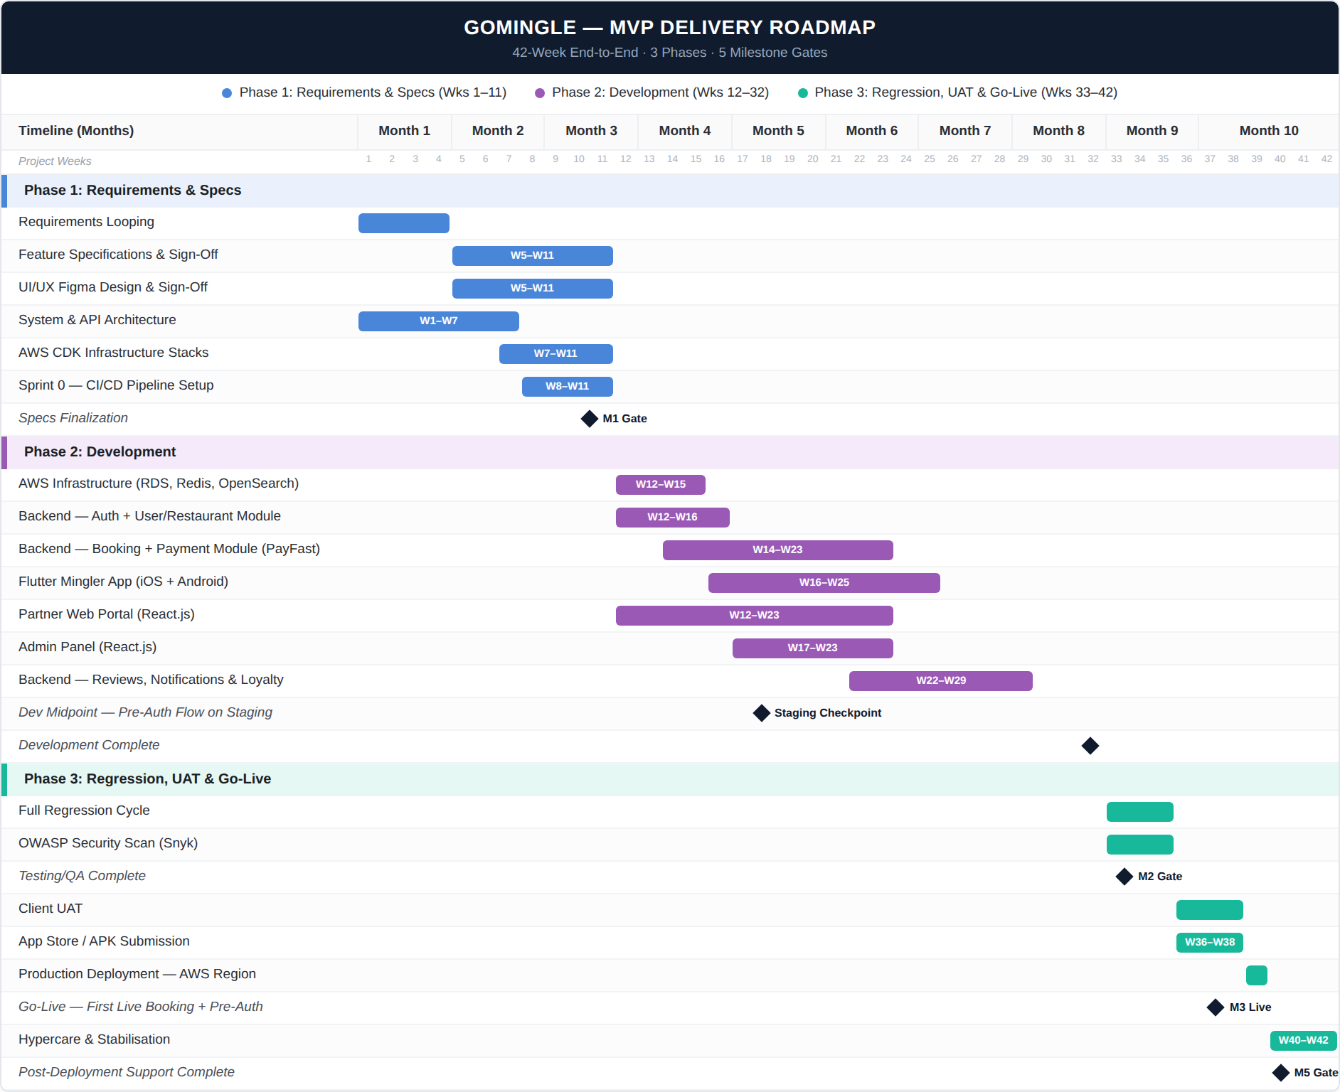
Our delivery approach is structured around a front-loaded specification and design phase, ensuring zero ambiguity before a single line of production code is written. Development proceeds in structured sprint cycles with full transparency, weekly deliverables checkpoints and clearly defined quality gates at each phase transition.

Phase Overview
Phase | Weeks | Duration | Focus | Key Gate
Phase 1 — Requirements & Specs | W1 – W11 | 11 Weeks | Requirements looping · Feature specifications & sign-off · UI/UX Figma design & sign-off · System & API architecture · AWS CDK infrastructure stacks · Sprint 0 — CI/CD pipeline setup | M1 — Setup, Requirements, Architecture & Design Sign-Off (W11)
Phase 2 — Development | W12 – W32 | 21 Weeks | AWS infrastructure provisioning (RDS, Redis, OpenSearch) · NestJS modular monolith — all 6 modules · PayPro/Safepay pre-auth lifecycle & NoShowOrchestrator · Flutter Mingler App (iOS + Android) · Partner Web Portal (React.js) · Admin Panel (React.js) · interim staging checkpoint for pre-auth flow (W20) | Development Complete — all modules & apps feature-complete (W32)
Phase 3 — Regression, UAT & Go-Live | W33 – W42 | 10 Weeks | Full regression cycle across platform · OWASP security scan via Snyk · Client UAT (W36–W38) · App Store + Google Play submission · Production deployment — AWS UAE Region · Hypercare & 30-day warranty (W40–W42) | M2 — Dev & Testing Complete (W35) · M3 — Go-Live: First Live Booking + Pre-Auth (W39)
Total | W1 – W42 | 42 Weeks | 3 Products · 16 Features · 50 Sub-Features

6. Project Cost Breakdown (Direct & Indirect Costs)
As an academic MS Practicum engagement with no commercial client or billing arrangement, this section presents the project's own cost structure — direct labor effort and indirect supporting costs — rather than a commercial pricing package.

6.1 Direct Costs — Team Effort & Labor
Resource | Role | Total Hours | Hourly Rate | Cost
Architect | Solution Architect / Tech Lead | 107 | $22 | $2,354
Project Manager (PM) | Project Manager | 214 | $20 | $4,280
Fullstack Engineer (BE) | Backend / Fullstack Developer | 213 | $18 | $3,834
Mobile Engineer (Flutter) | Mobile Developer (Senior) | 213 | $17 | $3,621
UI/UX Designer | UI/UX Designer | 213 | $14 | $2,982
QA Engineer | QA / Test Engineer | 213 | $12 | $2,556
Business Analyst (BA) | Business Analyst | 213 | $11 | $2,343
Fullstack Engineer 2 (Frontend) | Frontend / Fullstack Developer | 180 | $16 | $2,880
DevOps Engineer | DevOps / Cloud Engineer | 100 | $19 | $1,900
Total Direct Cost |  | 1,666 hrs | $16.06/hr avg | $26,750

6.2 Indirect Costs — Infrastructure, Tooling & Overheads
Item | Description | Estimated Cost
Cloud Infrastructure (AWS) | Dev + staging usage, leaning on AWS Free Tier where possible | $300
Apple Developer Program | Required annual fee to publish the Mingler App on the App Store | $99
Google Play Developer Account | One-time registration fee to publish on Google Play | $25
Domain Name & SSL | Domain registration (SSL via AWS ACM is free) | $20
Design, PM & Collaboration Tools | Figma, GitHub, Notion/Trello — used on free/student tiers | $0
Notifications & Third-Party APIs | Firebase Cloud Messaging free tier — sufficient at MVP scale | $0
Contingency Buffer | Unforeseen tooling, scope or infra needs | $256
Total Indirect Cost |  | $700
Note: indirect cost line items are estimates, not itemized vendor invoices — they assume dev/staging use of AWS Free Tier and free/student tiers for design and collaboration tooling.

6.3 Total Project Cost
 | Amount
Direct Cost (Labor) | $26,750
Indirect Cost (Infra, Tooling, Contingency) | $700
Total Project Cost | $27,450

7. Risk Management
Risk Category | Risk Description | Severity | Mitigation Strategy
Technical (Payments) | Payment gateway pre-auth edge cases: partial captures, timeouts, missed or double captures in the no-show detection window | HIGH | Pre-auth mechanic spec locked in Specs & Design phase. SQS Dead-Letter Queue ensures zero silent failures. Full PayPro/Safepay lifecycle tested in regression on a live test-mode account. Idempotency keys on all payment gateway API calls.
Technical (Concurrency) | Double-booking: two Minglers booking the same table simultaneously before slot lock is applied | HIGH | PostgreSQL row-level FOR UPDATE lock with 3-second timeout. Redis distributed lock as secondary guard. Explicit timeout returns "slot no longer available" error. Load-tested at 50 concurrent booking attempts.
Business (Adoption) | Restaurant partners resist the pre-auth mechanic, reducing supply-side onboarding velocity at launch | MEDIUM | No-show policy is fully configurable — restaurants set their own window and penalty amount. A zero-penalty configuration is valid for initial onboarding with hesitant partners.
Business (Chargeback) | UAE Minglers successfully dispute no-show charges via their bank, undermining the mechanic's enforceability | MEDIUM | PayPro/Safepay capture_method: manual pre-auth creates a formal authorisation record predating any capture — unchallengeable under standard UAE chargeback rules. Explicit consent timestamp stored in immutable audit log as evidence.
Operational (Single QA) | Single QA Engineer with 50 sub-features across 3 products, 3 platforms (iOS, Android, Web), and a complex payment-gateway pre-auth lifecycle creates a regression bottleneck | MEDIUM | Spec-based test case authoring in Specs & Design phase means test cases are written before code, reducing discovery time in regression. BA supports QA in Regression phase. Critical payment-gateway pre-auth paths prioritised as P0 test cases. 3-week regression window (W33–W35) provides sufficient buffer.
Technical (Infrastructure) | ECS Fargate cold start latency under burst traffic spikes degrades user experience at a critical conversion moment | MEDIUM | ECS Service Auto Scaling configured on ALB RequestCountPerTarget. Minimum task count set to 2 to eliminate cold starts on baseline traffic. CloudWatch alarms on P99 latency trigger scale-out before user impact. Load tested to 1,000 concurrent users in staging.

8. Project Sign-off

Approval
Practicum Supervisor | Student Team
________________  Name: Muhammad Kamran  Title: Supervisor, NUCES  Date: ______ | _________________  Names: Syed Rameez Ali, Rahim Ahmed Khan, Sheikh Raees Raza  NUCES — MS Practicum  Date: ______

